**PROJECT REPORT TEMPLATE**

**1. INTRODUCTION:**

**1.1 Description about Project: The world’s population is more than three times larger than it was in the mid-twentieth century. The global human population reached 8.0 billion in mid-November 2022 from an estimated 2.5 billion people in 1950, adding 1 billion people since 2010 and 2 billion since 1998. The world’s population is expected to increase by nearly 2 billion persons in the next 30 years, from the current 8 billion to 9.7 billion in 2050 and could peak at nearly 10.4 billion in the mid-2080s.**

**This dramatic growth has been driven largely by increasing numbers of people surviving to reproductive age, the gradual increase in human lifespan, increasing urbanization, and accelerating migration. Major changes in fertility rate have accompanied this growth. These trends will have far-reaching implications for generations to come.**

**1.1 Use of this project**

* **To improve the production of food grains**
* **Predict the future population of an area**
* **Help to develop the water resources**

**2. PROJECT DEFINITION AND DESIGN THINKING**

**2.1Empathy Map**

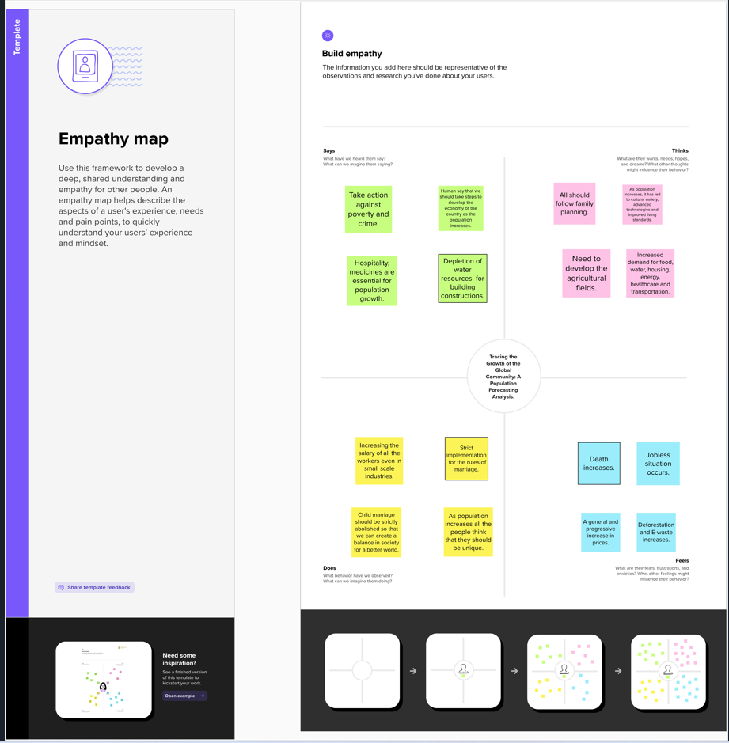

**2.2 BRAINSTORMING**

**3.RESULT:**

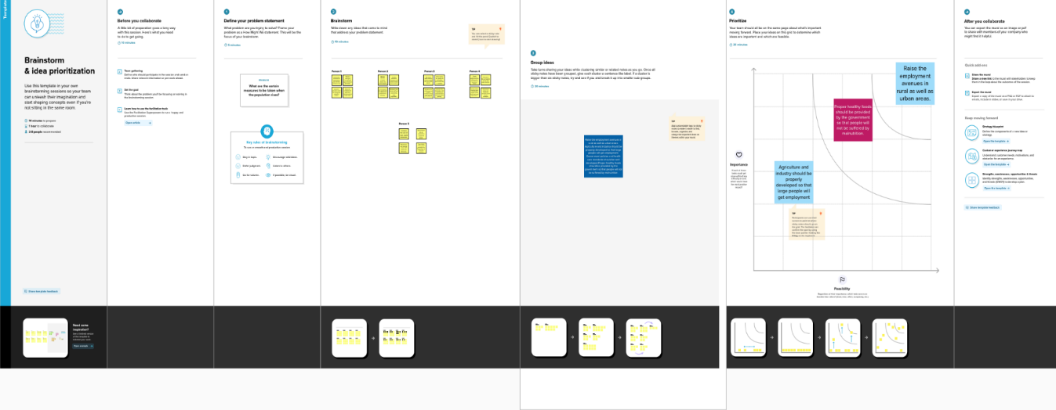

SHEETS:

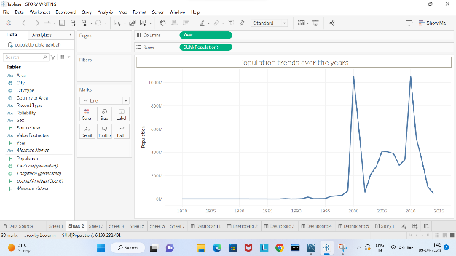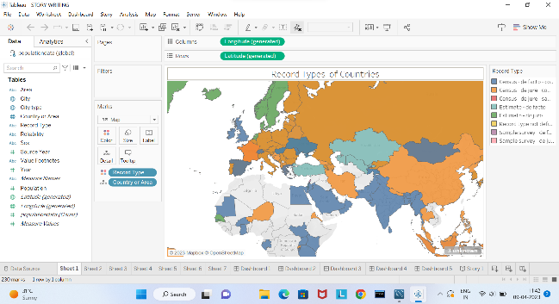

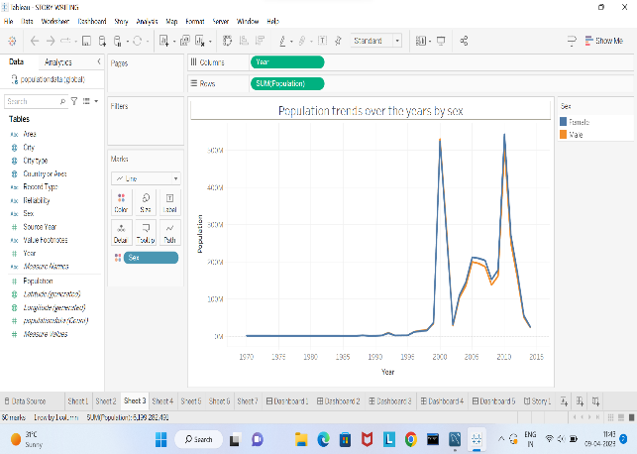

DASHBOARDS:

STORY:

4. ADVANTAGES AND DISADVANTAGES:

ADVANTAGES:

* This project helps us to know increase in the population in a particular area, city, etc..
* Helps us to develop the policies etc.,
* Helps to find a new way for the future needs.

DISADVANTAGES:

* If the population in the upcoming years increase or decrease the above output based on this dataset become invalid.

5. APPLICATIONS:

This project might be useful for analysis for increase in the population in future and helps us to find a necessary way for the production of goods, water resources etc..,

6.CONCLUSION:

The project “Tracing the growth of global community: A population forecasting Analysis” portrays the datas of population over the years by city, area, sex, etc., by analysing all these kinds we can find a solution to increase the production when the population increases.

7. FUTURE SCOPE:

To fulfil the future and further demands and various methods to increase the production of food materials, employment are also discussed.